林延 Lin Yan

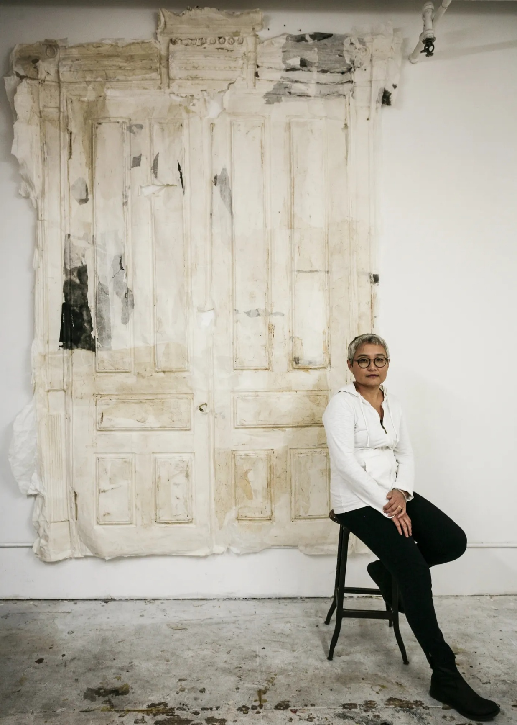
Photograph by Eugene Neduv ©2017 Lin Yan, courtesy Fou Gallery.

1961 | Born in Beijing, China
1984 | BFA, Department of Oil Painting, Central Academy of Fine Arts, Beijing
1986 | Atelier of Technique of Painting, L’École national supérieur des Beaux-Arts, Paris, France
1989 | MA, Department of Studio Art, Bloomsburg University of Pennsylvania, PA, USA
Now | Lives and works in New York, USA

Solo Exhibitions
2026 | Lin Yan: Alkaid, Yuan Art Museum, Beijing
2025 | Lin Yan: Everlasting Layers, French May Arts Festival Associated Exhibition, Alisan Atelier, Hong Kong
2023 | Lin Yan: Blowing in the Wind, Lens Gallery, Beijing
2021 | Lin Yan, Leo Gallery@West Bund Art & Design, Shanghai  Lin Yan: Lemaire-Beijing Gateway, Dover Street Market Taikooli, BeijingLin Yan: No Return, Art Basel Hong Kong, Hong Kong
2020 | Lin Yan: Regeneration of Hope, Leo Gallery, Art Basel Hong Kong, Online
2019 | Lin Yan: Origin Point, Helwaser Gallery, New York,
2018 | Lin Yan: Inverted Shadow, Leo Gallery, Shanghai
2017 | Lin Yan: Gateway, Fou Gallery, New York, USA
2016 | Lin Yan, Eslite Gallery, Taipei
2014 | Lin Yan: Beyond Xuan, Officina, Brussels, Belgium  Lin Yan: Dispelling the Clouds, Tenri Culture Institute, New York, USA  Lin Yan: Paperweight, Fou Gallery, New York, USA
2013 | Lin Yan: Embracing Stillness, Sprint Flatiron Prow Art Space, Cheryl McGinnisProject, New York, USA
2012 | Lin Yan: Enshrouded, Cheryl McGinnis Gallery, New York, USA
2008 | Lin Yan: Remaking, China Square, New York, USA
2006 | Lin Yan: Echoes in the Moment, China 2000 Fine Art, New York, USA
1996 | Lin Yan: To Beijing, Open House Exhibition, New York, USA
1991 | Lin Yan: The Beginning, Twin Cranes Gallery, Seattle, USA
1988 | Lin Yan: Tai Chi in Painting, Haas Gallery, Bloomsburg University of Pennsylvania, PA, USA

Selected Group Exhibitions
2026
Paper and Water: Shanghai International Paper Art Biennale, Fengxian Museum, Shanghai
An Alternative Path to Modernity 2026: Returning from North America, ArtAlpha & Made Oriental Culture, Hangzhou
Poetic Ink Strokes, Wuchangshuo Art Museum, Shanghai
Soft Symbiosis: 2026 International Invitational Exhibition of Women Artists, Huaping ART, Ningbo
2025
Art on Paper: Exhibition of the Artistic Energy of Paper, OCT Art & Design Gallery, Shenzhen
West Bund Art & Design Fair, Alisan Fine Arts, Shanghai
2024
Pure Painting: Spring Equinox (II), Yan Art, Beijing
Whispers of Time, Leo Gallery, Shanghai
2023
Seeking the City: 2023 Datong Contemporary Art Season, Southeast Historical and Cultural District, Datong
In the Mood for Love: Chinese Female Artists from Song Dynasty to Modern Day, VillageOne Space, New York, USA
Mountain Ridge, WS Gallery, Shanghai
Beyond Ink, Eslite Gallery, Taipei
2022
When All At Once I Turn My Head, I Find Her There Where Lantern Light Is Brightly Shed, Art Museum of Nanjing University of the Arts, Nanjing
From Lausanne to Beijing: 12th International Fiber Art Biennial, Yunnan Provincial Museum, Kunming
My Casa, AD Magazine Art Space, Shanghai
2021
Big in China, White Rabbit Gallery, Sydney, Australia
Super Fusion: 2021 Chengdu Biennial, Chengdu City Art Museum, Chengdu
In the Midst of It All, G Museum, Nanjing
Carry-On III, Yuan Art Museum, Beijing
Spring Fever 2021, Platform China Contemporary Art Institute, Beijing
2020
Re-Destination, Yuan Art Museum Wuqing, Tianjin
Reflecting the Sharing Moment, Central Academy of Fine Arts online exhibition, Beijing
Salon Salon: Contemporary Art Practices from 1972-1982 in Profile: A Beijing Perspective, Art Museum of Guangzhou Academy of Fine Arts, Guangzhou
A Tale of Two Cities: New York, VillageOne Space, New York, USA
Clouds Gathering and Unfolding: An Exhibition of Modern Chinese Art on Paper, Ichihara Lakeside Museum, Chiba-ken, Japan
2019
Mind Your Gap, The Delaware Contemporary, Delaware, USA
The Latent Paradigm, Research on the Status and Ecology of Chinese Contemporary Art 2019, Today Art Museum, Beijing
The Splendid Languages of Paper, Zhejiang Art Museum, Hangzhou
Cross-Cultural Practice: Recent Works by Chinese Artists in New York, New York City College of Technology, New York, USA
A Material Lineage: Pang Tao and Lin Yan, Pearl Lam Gallery, Shanghai
2018
New Ink Art in China 1978-2018, Minsheng Art Museum, Beijing
The 2018 Guang’an Field Art Biennial, Baozhensai, Guang’an
2017
Useless Value: Lin Yan, Yin Xiuzhen, Ai Jing, Wanying Art Space, Shijiazhuang
Loom: Contemporary Art, Jinji Lake Art Museum, Suzhou
Crisscrossing East and West: The Remaking of Ink Art in Contemporary East Asia, Museum of Contemporary Art, Yingchuan
The Dark Matters, White Rabbit Gallery, Sydney, Australia
Twenty Years of Contemporary Ink Art at Kaikodo, Kaikodo Gallery, NewYork, USA
Art Exhibition of Elegant Items of Ingenuity 201 7, Shixiang Art Space, Beijing
2016
3rd CAFAM Biennial, Art Museum of Central Academy of Fine Arts, Beijing
In Perspective, Chambers Fine Art, New York, USA
Boundaries of the Spirit, Nanhai Art, San Francisco, USA
2015
Sovrapposizioni Di Immagini, Casa Dei Carraresi, Treviso, Italy
Lin Yan & Wei Jia: A Garden Window, Kwai Fung Hin Gallery, Hong Kong
2014
Double Vision: The Culture China - Overseas Chinese Women Invitational Exhibition, He Xiangning Art Museum, Shenzhen
China Twelfth National Art Exhibition: Mixed Media Paintings, Hebei Museum, Shijiazhuang
Modernity 3.0: Bridging East-West Art, 80 WSE Gallery, New York University, New York, USA
Tales of Two Cities: New York & Beijing, Bruce Museum, Greenwich, CT, USA
Transcending Boundaries, Amy Simon Fine Art, Westport, USA
Start from Tradition: Lin Yan & Wei Jia, Cheryl McGinnis Gallery, New York, USA
2013
New York Beijing, Here There, Yuan Art Museum, Beijing
2012
Art on Paper 2012 Biennial, Weatherspoon Art Museum, University of North Carolina, Greensboro, NC, USA
4th Taipei Contemporary Ink Painting Biennial, National Democracy Memorial Hall, Taipei
Phoenix Singing: Traveling Exhibition of Contemporary Female Art, Tree Museum, Beijing
Vaulting Limits, Tenri Cultural Institute, New York, USA
2011
Art on Paper, Gallery North, Long Island, New York, USA
Asian Variegations, Chelsea Art Museum, New York, USA
2011 Paper Art Biennial, National Art Gallery, Sofia, Bulgaria
Giving and Receiving: A Collaborative Exhibition of Contemporary Artists from China and USA, CU Art Museum, University of Colorado, Denver, USA
2010
3rd Contemporary Ink Painting Biennial, Taipei National Museum of History, Taipei
Spring Equinox, Yuan Art Museum, Beijing
Echoes from the Past, Amy Simon Fine Art, Westport, USA
Intertwining Layers, Cheryl McGinnis Gallery, New York, USA
2009
Living Ink, Gallery Korea, Korean Cultural Centre, New York, USA
Here & Now: Chinese Artists in New York Chapter 1, Museum of Chinese in America, New York, USA
Making It, Deutsche Bank 60 Wall St. Gallery, New York, USA
2008
Art Graduate Reunion Exhibition: Class of 1980, Studio III, Department of Oil Painting: Celebrating 90th Anniversary of Central Academy of Fine Arts, Loft 3 Gallery, 798 District, Beijing
Shanghai MoCA Envisage II: Butterfly Dream, Museum of Contemporary Art, Shanghai
Cross Reference: 11 Artists from NY, Shuimo Art Space, 798 District, Beijing
Then and Now: Chinese Art from 1710 to 2007, Lamont Gallery, Phillips Exeter Academy, Exeter, NH, USA
Chinese Gardens for Living: Illusion into Reality, The Dresden State Art Collections, Germany
The Transforming Marks of Ink, The Dresden State Art Collections, Germany
Chinese Traditions Reconfigured, Amy Simon Fine Art, Westport, CT, USA
From Realism to Abstract: The 2nd exhibition of Chinese Abstraction, One Moon Contemporary, Beijing
Cross Reference: 11 Artists from NY, Shuimu Art Space, Beijing
2007
Touched by Women’s Hands, curated by Lin Yan, Smithsonian Institution, Flushing Town Hall, New York; Cheryl McGinnis Gallery, New York, USA
Qi Yun: International Traveling Exhibition of Chinese Abstract Art, He Xiangning Art Museum, Shenzhen, China; Artist Commune, Hong Kong; China Square, New York, USA
Art Beijing, National Agricultural Exhibition Centre, Beijing
3rd Chengdu Biennial, Chengdu Contemporary Art Museum, Chengdu
Responding & Corresponding, National Art Museum of China, Beijing
In and Out, 2x13 Gallery, New York, USA
Language / Environment, Contemporary Museum of Art of Beijing, Beijing
Transparent: Group Exhibition by Lin Yan, Zhang Hongtu, Hu Bing, Cheryl McGinnisGallery, New York, USA
2006
Curators’ Choice: China, Art, Complex Museum, Duxbury, MA, USA
Transplant-Transculture, Wave Hill, Bronx, NY, USA
Travelers Between Cultures: Xu Bing, Gu Wenda, Lin Yilin, Lin Yan and Zhang Hongtu, Visual Arts Centre of New Jersey, NJ, USA
Trans-Boundary Experiences, Spool MFG, Binghamton, NY, USA
Brooklyn, Westport Arts Centre, CT, USA
New Chinese Occidentalism: Chinese Contemporary Art in NY, Ethan Cohen Fine Arts, New York, USA
Contemporary Chinese Visions, Amy Simon Gallery, Westport, USA
Visible / Invisible: Chinese Abstract Paintings Exhibition, One Moon Contemporary, Beijing
2005
Simplicity in Life, Crystal Foundation Gallery, New York, USA
Simplicity in Life 2, William Fellows Architects, New York, USA
2003
Between the Lines, curated by Lin Yan, China 2000 Fine Art, New York, USA
The Paper Chase: Creations in Paper, curated by Lin Yan, China 2000 Fine Art, New York, USA
2002
Visual Dialogue, curated by Lin Yan, China 2000 Fine Art, New York, USA
2000
Art Span: Three Generations, Nine Artists in One Family, Satellite Show of Shanghai Biennial, Shanghai
1999
Global Roots: Artists from China Working in New York, Purdue University, West Lafayette, IN, USA
1998
Three Generations of Chinese Modernism: Qiu Ti, Pang Tao, Lin Yan, Soho20 Gallery, New York, USA; Art Beatus Gallery, Vancouver, Canada; National Art Museum of China, Beijing
1995
Recent Paintings by Chinese-American Artists, Cork Gallery, Avery Fisher Hall, Lincoln Centre, New York, USA
NY Soho Biennial ’95, 450 Broadway, New York, USA
Man Woman Child/ Husband Wife Son, Gallery Contempo, Jubilee Arts Centre, New York, USA
1994
Qi, Art Museum of Central Academy of Fine Arts, Beijing
1991
Second Spring: Contemporary Chinese Painting & Sculpture, University of San Diego, San Diego; San Diego State University, San Diego, USA
1990
Pang Family Painting Exhibition, Lung Men Art Gallery, Taipei
1987
From Central Academy of Fine Arts, Museum of Tokyo University of Fine Arts and Music, Tokyo, Japan
1985
National Youth Art Exhibition, National Art Museum of China, Beijing
1984
Beijing City Art Exhibition, National Art Museum of China, Beijing
1979
1st Annual Exhibition of China Oil Painting, Association Zhongshan Park, Beijing

Selected Collections
Deutsche Bank Art Corporate Citizenship Art, New York, USA
White Rabbit Gallery, Sydney, Australia
Museum of Central Academy of Fine Arts, Beijing
Yuan Art Museum, Beijing
Long Museum, Shanghai
Chengdu Contemporary Art Museum, Chengdu
Teda Contemporary Art Museum, Tianjin
Pang Xunqin Museum, Changshu

